**UMBC COEIT Advising Website – Updates and Changes**

**[Changes Summary]**

- All website files can be found in the **Website Files** folder.

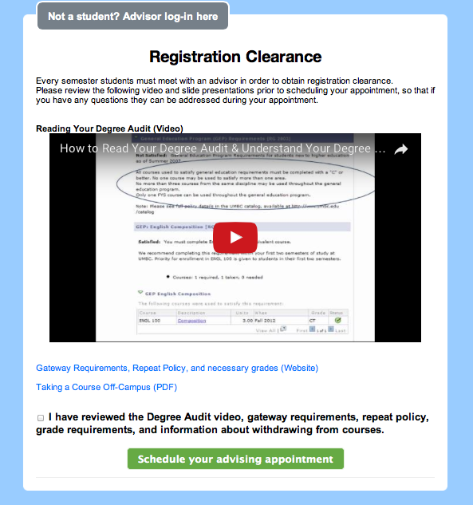  
- **added a Registration Clearance page (registrationClearance.php)**  
Students must first view a video and read through provided links in order to familiarize themselves with the advising process.   
They cannot proceed to the student login until they have checked the agreement at the bottom of the page.  
The student does not need to go through this agreement again as long as their session is active.  
  
This Registration Clearance page also serves as the index for the website; Advisors can access their own login through the button in the top-left corner.

**- Small visual and layout updates for convenience and ease of use**Button and page elements were repositioned and relabeled to make the website more easy to navigate and informational for the user.   
Some redundant pages were consolidated, such as the student-side appointment viewer (04StudViewApp.php), where it will now display appointment information along with Rescheduling and Canceling buttons within the same page.   
Previously, these two buttons showed on the Student menu page (02StudHome.php),   
  
Back/Return to Home buttons on various parts of the website now direct back to the page before it, as opposed to the Student menu or Advisor menu, in order to allow easier backtracking for scheduling the proper appointment.  
  
The visuals and layout of the website has remained the same, but all css has been consolidated to an external css stylesheet, found in the **Web Files/css** folder.  
Please keep the css folder where it currently is, or it may break the pages.

**- Changes to function**  
Group meetings now will be assigned to the advisor making the appointment, as opposed to a blank ‘Group’ advisor. The website now displays explicitly whether or not the appointment is an Individual or Group type, and also show the number of students currently enrolled.  
  
Advisors can now set a **Meeting Room** to their accounts, which will reflect as the meeting location for the appointments they create. The database structure has been updated to accommodate this addition; please refer to the **DataBase-setup.doc** file for more information.  
  
Advisors can also add a specified student to a new Individual appointment by entering their student ID in a field given in the appointment creation page (AdminScheduleInd.php).

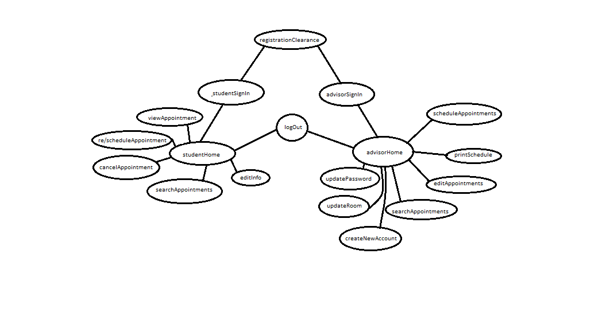  
**[Website Flow]**

A diagram of the general website flow.  
There are two major modes: Student side and Advisor side, centered around **studentHome (02StudHome.php)** and **advisorHome (AdminUI.php).**   
Both Home pages are prefaced by a respective sign-in page (**01StudSignIn.php** and **AdminSignIn.php**).  
Students cannot access the studentSignIn proper until they have passed through the registrationClearance (**registrationClearance.php**), which serves as the index of the website until passed.  
Essentially, studentHome and advisorHome serve as the menu for each side.

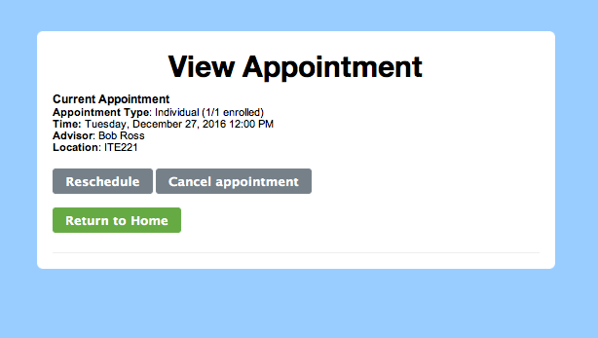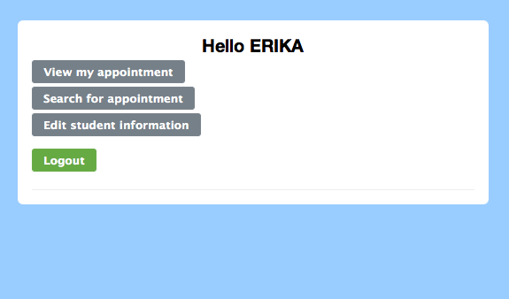**[Student Side]**Students can view/schedule appointments, search for appointments, and edit student information.  
**-View appointment**

Displays current appointment info, as well as a Reschedule and Cancel command.  
  
If there is no appointment, the button will be labeled ‘Signup for an Appointment’, and it will take the user to the re/schedule appointment process.  
  
Student information will not be saved in the database until they enroll in at least 1 appointment after their initial log in.

**-Search for appointment**

Allows student to search for appointments fitting their criteria.

**-Edit student information**

Allows student to update their name, email, or major.

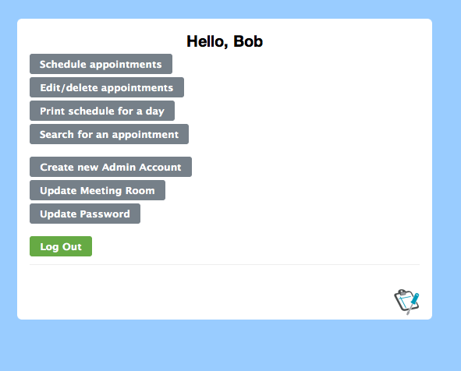

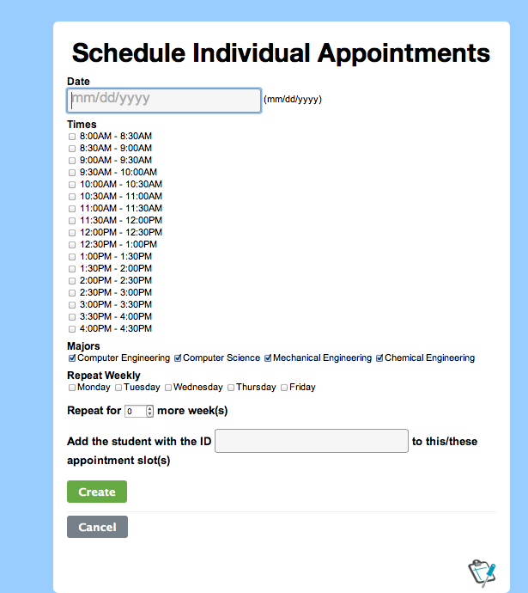**[Advisor Side]**  
Advisors can set up new appointments (individual or group), edit/delete appointments, search appointments, and print an appointment schedule for a given date.  
  
Advisors also have the privilege of creating new advisor accounts; this is the only way to create admin accounts formally through the website.